Final report

Now that you have explored the bakery dataset using spreadsheets, it is time to write down the report to show stakeholders.

By the end of this quiz you will have a full report about the data. You just need to choose the correct answer from different drop-down menus, based on your dataset exploration.

Good luck!

The following question contains 2 dropdown responses.

### **1.**

Question 1

# **Problem definition**

Opening a bakery in Korea presents a promising business opportunity, but it requires a deep understanding of the market dynamics to ensure success. The bakery industry is highly competitive, with a wide range of products catering to diverse consumer preferences. To establish a thriving bakery, it is essential to analyze the data to get insights into consumer behavior, product popularity, and optimal business operations.

The primary objective of this data analysis is to

identify the types of bakery items that are most popular among consumers in Korea

​

. By examining sales data, we can determine which products are in high demand and tailor our offerings accordingly. This includes understanding preferences for different types of bread, pastries, cakes, and other baked goods, as well as beverages including coffee, tea and soft drinks.

In addition to product popularity, it is crucial to

analyze the time periods during which bakeries experience the highest sales

​

. Understanding peak hours and days can help in optimizing staffing, inventory management, and promotional strategies. For instance, if data reveals that sales spike during weekends or specific times of the day, we can plan accordingly to maximize revenue and customer satisfaction.

By gaining insights into these factors, we can develop a comprehensive business strategy that addresses market demands and enhances operational efficiency. Ultimately, the goal is to leverage data-driven insights to create a successful bakery that meets the needs and preferences of the Korean market.

### **Response 1**

understand whether you should incorporate catering for pets into your bakery.

identify the types of bakery items that are most popular among consumers in Korea

identify various customer segments and understand which items are frequently bought together.

**Correct**

This can help you understand which products you want to sell in your bakery

### **Response 2**

analyze time periods when people show up with their pets

analyze the time periods during which bakeries experience the highest sales

**Correct**

This can help you with staffing the bakery and keeping enough items in stock.

2 / 2 points

The following question contains 3 dropdown responses.

### **2.**

Question 2

# **Data**

The data utilized for this analysis was sourced from

a Kaggle dataset

​

. This dataset was compiled by an individual who worked part-time at a small bakery in Korea. The bakery began its delivery service in July 2019, using the Bea Min platform to reach a wider customer base. The creator of the dataset collected and analyzed this information to share valuable insights with their coworkers. The dataset includes detailed transaction records, capturing various aspects of sales performance both in-store and through delivery, providing a rich foundation for understanding consumer preferences and optimizing business operations.

The dataset is structured as basket data, containing

31

​

columns that capture various aspects of each transaction. This comprehensive dataset provides a detailed overview of sales, enabling a thorough analysis of consumer preferences and purchasing patterns.

# **Data preprocessing**

The data contained a few empty rows, which had to be removed, but apart from that, it was already cleaned, so no additional cleaning steps were necessary.

To perform the analysis, a few new features were created: the datetime column was split into

year, month, day and hour

​

columns in order to visualize the time dependencies using different independent variables. The data was then aggregated across the hour column and the month and year columns. Separately, aggregations per product were done to see the comparison between the products.

### **Response 1**

various Korean bakeries just to prove that mom was wrong.

a Kaggle dataset

an old bakery owned by my aunt.

a report about bakeries published by the South Korean government.

**Correct**

Open source datasets can be very useful when doing some initial research.

### **Response 2**

20

31

**Correct**

After preprocessing, this dataset contains 31 features.

### **Response 3**

month and day

year, month, day and hour

hour, minute and second

**Correct**

3 / 3 points

The following question contains 4 dropdown responses.

### **3.**

Question 3

## **Time trends of sales**

**Income Trends by Hour**

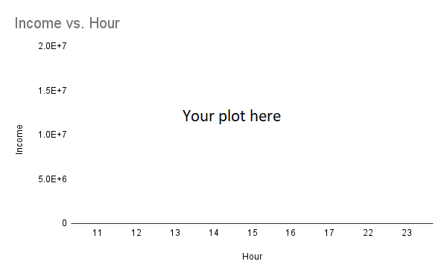

The total income by the hour of the day indicates that the highest income is generated during

the morning

​

hours, with a significant peak at the opening time at

11 am

​

. This suggests that a

substantial

​

portion of the bakery's revenue comes from morning customers, likely those purchasing breakfast items or coffee on their way to work.

Following the peak, there is a gradual

decrease

​

in income as the day progresses. This highlights the importance of the morning rush, emphasizing that the bakery should focus on optimizing operations during these peak hours. Ensuring that popular items are freshly stocked and staff are adequately prepared to handle the morning influx can maximize sales and enhance customer satisfaction.

### **Response 1**

the morning

lunchtime

late evening

**Correct**

When you look at the hourly trend, you can see that the highest sales actually happen in the morning, with sales dropping steadily in the afternoon.

### **Response 2**

11 am

1 pm

5 pm

**Correct**

When you look at the hourly trend, you can see that the highest bar in the plot covers the opening hours

### **Response 3**

substantial

small

**Correct**

Since most income happens during the morning, this represents an important part of the shop's revenue

### **Response 4**

decrease

increase

**Correct**

As you should be able to see in the plot, after the morning peak sales decrease as the day goes by

4 / 4 points

The following question contains 1 dropdown response.

### **4.**

Question 4

### **Income Trends by Day of Week**

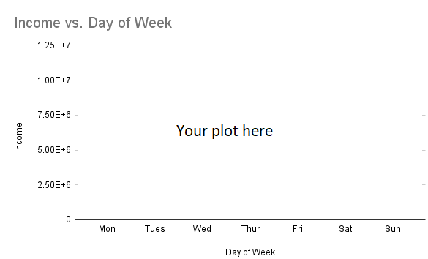

The analysis of income trends by day of the week reveals a steady increase in income as the week progresses, with a significant peak on

Sundays

​

.

The lower income observed especially on Mondays, indicates that customer traffic is lighter during these days. This insight can inform strategic decisions regarding staffing and inventory management. For instance, the bakery might consider scheduling fewer staff members and maintaining lower inventory levels at the start of the week to reduce operational costs. Given the upward trend, it may make the most sense to close the bakery on Mondays rather than Tuesdays.

### **Response 1**

Monday

Saturday

Tuesday

Sundays

**Correct**

1 / 1 point

The following question contains 2 dropdown responses.

### **5.**

Question 5

## **Product trends**

### **Best selling Items**

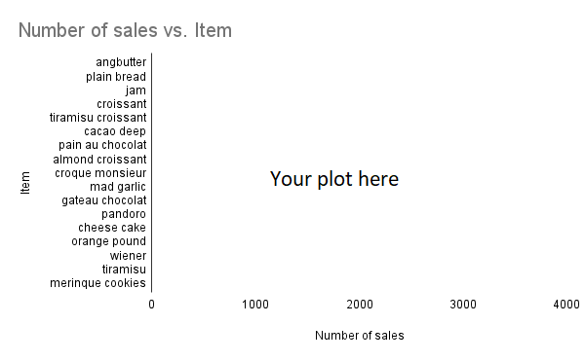

The analysis of food items reveals that certain products significantly drive revenue, with the

Angbutter

​

standing out as the top performer. This indicates a strong customer preference for unique and culturally resonant items. The popularity of this item suggests that incorporating traditional Korean flavors and ingredients into the bakery's offerings can be a highly effective strategy. Other high-performing items include staples like croissants and plain bread, highlighting the importance of offering universally appealing and versatile products.

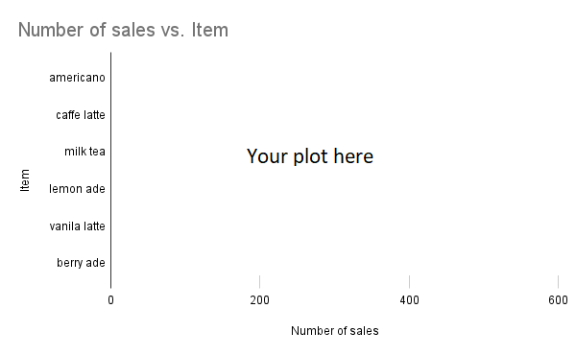

The analysis of beverage sales reveals a clear preference for

americano

​

among customers, with Americano coffee significantly leading in sales volume. This indicates a strong demand for classic coffee options, which are likely favored for their simplicity and wide appeal. In contrast, cold drinks like lemonade and berry-ade are not performing as well, suggesting that they cater to a smaller segment of the market.

Despite these preferences, it is important to note that beverage sales constitute only about 10% of the bakery's total sales. This highlights that the primary focus should remain on food items, which drive the majority of revenue. However, given the popularity of americano and hot drinks like caffe latte, it is advisable to expand the selection of classic coffee options, such as different types of lattes and cappuccinos, to complement the bakery's food offerings. Maintaining a limited stock of long shelf-life cold drinks can still accommodate the minority who prefer them.

### **Response 1**

Croissants

Angbutter

Gateau chocolat and tiramisu croissants combined.

Meringue cookies

**Correct**

### **Response 2**

milk tea

americano

**Correct**

2 / 2 points

The following question contains 1 dropdown response.

### **6.**

Question 6

### **Hourly sales of individual items**

The next two plots show how different items sell in different times of day. Each row represents a certain item and is normalized so the sum of all numbers in a row adds to one. Thus each number in the matrix shows a fraction of sales of the certain item in a given hour of day.

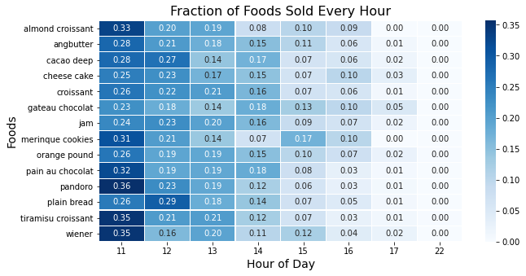

When taking all different food items into account, we can see that they all sell best during the morning hours. This pattern underscores the importance of the breakfast rush, as customers are more likely to purchase bakery products during this time.

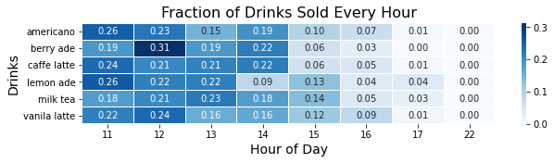

Looking separately at the drinks, we can see a similar pattern, however we can notice that the values are lower in the morning, but stay slightly higher later in the day. To highlight that, we plot the aggregate hourly sales of all drinks compared to the aggregate hourly sales of all foods on the plot below. Again each point on the graph represents the percentage of sales for food or drinks in a given hour.

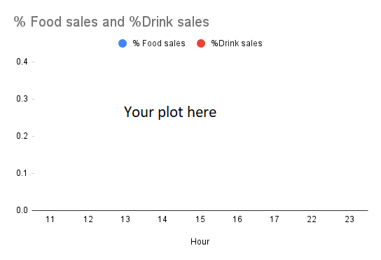

Comparing the sales of foods and drinks reveals an interesting pattern:

while the sales of both foods and drinks decline through the day, but the sales of drinks decay at a lower rate until 2 pm

​

This likely represents the afternoon coffee break (americano especially peaks at that time) that people take during their working hours. Understanding this behavior can help the bakery optimize its offerings to cater to this specific demand and potentially boost sales. Additionally, promoting afternoon specials or discounts on beverages can attract more customers looking for a mid-day refreshment.

### **Response 1**

while the sales of both foods and drinks decline through the day, but the sales of drinks decay at a lower rate until 2 pm

the sales of foods decline through the day, and the sales of drinks increase through the day.

the sales of both foods and drinks decline through the day, but the sales of foods have another small peak at 2 pm.

while the sales of both foods and drinks decline through the day, but the sales of foods have another small peak at 4 pm

**Correct**

This is likely due to a coffee break people take after lunch.

1 / 1 point

The following question contains 1 dropdown response.

### **7.**

Question 7

# **Conclusion**

The analysis indicates a strong preference for

unique, culturally resonant items like Angbutter, alongside staple products such as croissants and plain bread

​

. Additionally, hot beverages like Americano and Caffe Latte are highly favored, particularly during morning hours and again around 2 PM, reflecting the typical coffee break. While beverages constitute only about 10% of total sales, maintaining a diverse and high-quality selection of these popular drinks, complemented by a few long shelf-life cold options, can enhance the overall customer experience.

To maximize success, the bakery should focus on optimizing operations during peak morning hours, ensuring popular items are freshly stocked and staff are prepared to handle high demand. Given the significant sales volume on weekends, strategic staffing and inventory management can further enhance efficiency and profitability. An important thing to further look into are the monthly fluctuations, which can be as high as 50%.

By understanding and responding to these consumer preferences and purchasing behaviors, the bakery can position itself effectively in the competitive Korean market, attracting a loyal customer base and driving sustained growth.

### **Response 1**

plain croissants, leaving no place for unique, culturally resonant items

unique, culturally resonant items like Angbutter, alongside staple products such as croissants and plain bread

**Correct**

There are other items that sell better or equally as good as croissants that make sense to include on the menu. However, be aware that in a business analysis no answer is 100% correct! Your croissants might be different from the croissants sold by the bakery whose data you analyzed. It might be that your mom was correct and they would become famous and sell better than anything else. She’s holding onto hope!